Sample Question:
A digital signature provides for data integrity and a MAC provides for data integrity. Why does a digital signature also provides for non-repudiation while a MAC does not?
Answer:
• MAC (Message Authentication Code): এটি সিমেট্রিক কি (Symmetric Key) ব্যবহার করে। এর মানে হলো, প্রেরক (Alice) এবং প্রাপক (Bob) দুজনের কাছেই একই গোপন চাবি (Shared Secret Key) থাকে। যেহেতু দুজনের কাছেই একই চাবি আছে, তাই Bob চাইলেই Alice-এর নামে একটি ভুয়া মেসেজ তৈরি করতে পারে। যদি Alice পরে অস্বীকার করে যে সে মেসেজটি পাঠায়নি, তবে Bob তৃতীয় কারো কাছে প্রমাণ করতে পারবে না যে এটি Alice-ই পাঠিয়েছে, কারণ Bob নিজেও সেটি তৈরি করার ক্ষমতা রাখে। তাই এতে নন-রেপুডিয়েশন নেই।
• ডিজিটাল সিগনেচার (Digital Signature): এটি পাবলিক কি (Public Key) ক্রিপ্টোগ্রাফি ব্যবহার করে। এখানে Alice তার নিজস্ব প্রাইভেট কি (Private Key) দিয়ে মেসেজ সাইন করে, যা পৃথিবীতে আর কারো কাছে নেই। Bob বা অন্য যে কেউ Alice-এর পাবলিক কি দিয়ে তা যাচাই করতে পারে, কিন্তু কেউ সেটা জাল করতে পারে না। যেহেতু এই সিগনেচার শুধুমাত্র Alice-এর চাবি দিয়েই সম্ভব, তাই সে পরে অস্বীকার করতে পারে না যে মেসেজটি সে পাঠায়নি। একেই বলে নন-রেপুডিয়েশন।
Non-non-repudiation:
❑ Alice orders 100 shares of stock from Bob ❑ Alice computes MAC using symmetric key ❑ Stock drops, Alice claims she did not order ❑ Can Bob prove that Alice placed the order? ❑ No! Bob also knows the symmetric key, so he could have forged the MAC ❑ Problem: Bob knows Alice placed the order, but he can’t prove it
Non-repudiation:
❑ Alice orders 100 shares of stock from Bob ❑ Alice signs order with her private key ❑ Stock drops, Alice claims she did not order ❑ Can Bob prove that Alice placed the order? ❑ Yes! Alice’s private key used to sign the order ⎯ only Alice knows her private key ❑ This assumes Alice’s private key has not been lost/stolen

Sample Question:
Consider the elliptic curve E : y2 =x3 + 7x + b (mod 11).
a. Determine b so that the point P = (4,5) is on the curve E.
b. Using the b found in part a, list all points on E.
c. Using the b found in part a, find the sum (4,5) + (5,4) on E.
d. Using the 6 found in part a, find the point 3(4,5).
Answer:
Given:
Elliptic Curve:
👉 E : y2=x3+7x+b (mod 11)
E: y² = x³ + 7x + b (mod 11)
Point:
👉 P=(4,5)
✅ (a) Find b
Point (4,5) curve এ বসাই:
👉 Left side:
y2=52=25≡3 (mod 11)
👉 Right side:
x³+7x+b
=4³+7×4+b
= 64+28+b
=92+b
👉 mod 11:
92≡4
So, RHS = 4+b
👉 Equation:
3=4+b (mod 11)
👉 b=3−4=−1≡10 (mod 11)
✔️ Answer: b=10

(b) Using the b found in part a, list all points on E
Find all points on:
👉 y²=x³+7x+10 (mod 11)
👉 Step 1: আগে mod 11 এ square values (y²) কী কী হতে পারে সেটা লিখে রাখো
y | y² mod 11
0 | 0
1 | 1
2 | 4
3 | 9
4 | 5
5 | 3
6 | 3
7 | 5
8 | 9
9 | 4
10 | 1

Step 2: এখন x বসাই (0 → 10)
আমরা শুধু check করবো RHS এই set এর মধ্যে পড়ে কিনা
y²=x³+7x+10 (mod 11)
✔️ x = 0
RHS = 10 ❌ (not in list)
✔️ x = 1
RHS = 7 ❌
✔️ x = 2
RHS = 10 ❌
✔️ x = 3
RHS = 3 ✔️
👉 y² = 3 → y = 5, 6
✔️ (3,5), (3,6)
✔️ x = 4
RHS = 3 ✔️
👉 y = 5, 6
✔️ (4,5), (4,6)
✔️ x = 5
RHS = 5 ✔️
👉 y = 4, 7
✔️ (5,4), (5,7)
✔️ x = 6
RHS = 4 ✔️
👉 y = 2, 9
✔️ (6,2), (6,9)

✔️ x = 7
RHS = 6 ❌

✔️ x = 8
RHS = 6 ❌

✔️ x = 9
RHS = 10 ❌

✔️ x = 10
RHS = 2 ❌

✅ Final Answer (Very Important)
👉 All points:
✔️ (3,5), (3,6)
✔️ (4,5), (4,6)
✔️ (5,4), (5,7)
✔️ (6,2), (6,9)
👉 + Infinity point (O)

✅ Problem (c)
Using the b found in part a, find the sum (4,5) + (5,4) on E.

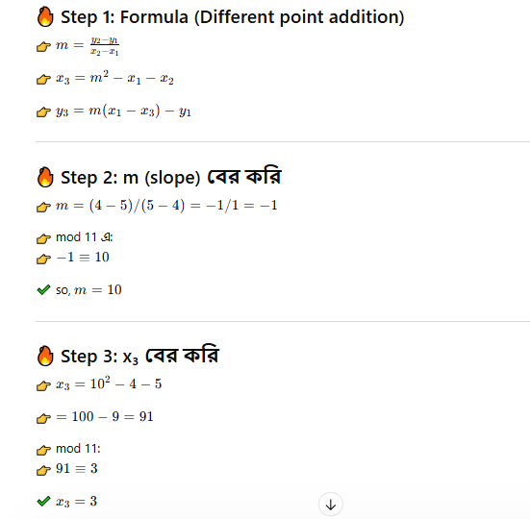

d. Using the 6 found in part a, find the point 3(4,5).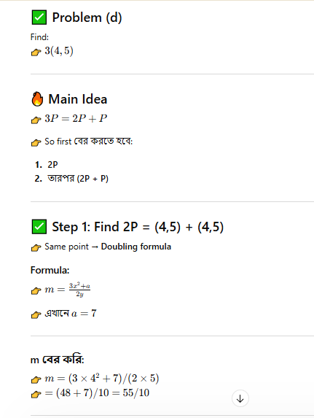
Ekhane m er man ber korar jonno ei sutrota lagbe
a*x≡1 (mod p)
55 mod 11 = 0
but 10 er jonno sutrota apply hobe
tar mane 10 er sathe koto gun korle and tar sathe 11 mod korle = 1 hobe? Eta mainly concept
10*10 mod 11 = 1
=> 10⁻¹ = 10
Tar mane m = 0 * 10⁻¹ = 0 *10 = 0
Evabei m er man ta ber koreche
^{aro ekta example dilam}
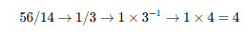
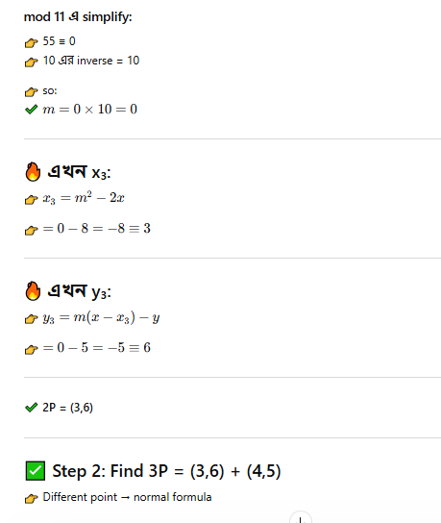
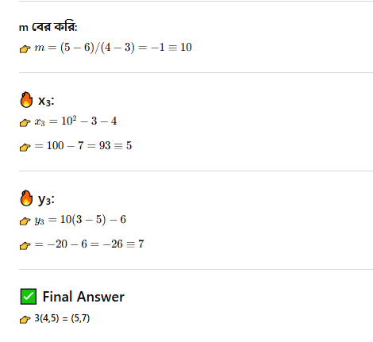

Question: What is an Elliptic Curve?
Answer: An elliptic curve E is the graph of an equation of the form y 2 = x3 + ax + b ❑ Also includes a “point at infinity”
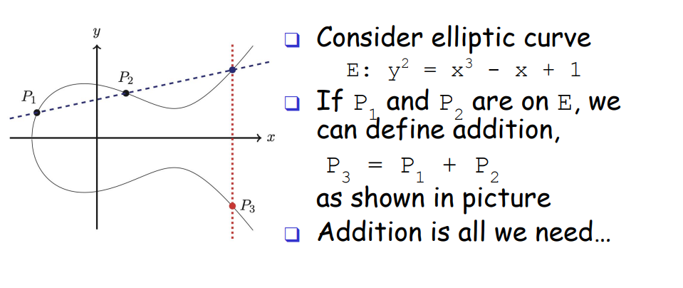
Question: What is the primary purpose of the Diffie-Hellman (DH) algorithm? Can it be used for encryption or digital signatures?
Answer: The purpose of DH is Key Exchange—to establish a shared symmetric key over an insecure channel. It is not designed for encryption or digital signing.
Question: What mathematical problem is the security of Diffie-Hellman based on?
Answer: It is based on the Discrete Logarithm Problem (Given g^{k} (mod p), it is computationally hard to find the exponent k).
Question: Explain the Man-in-the-Middle (MITM) attack on Diffie-Hellman. How can it be prevented?
Answer: In an MITM attack, an attacker (Trudy) intercepts the messages between Alice and Bob. Alice thinks she is talking to Bob, and Bob thinks he is talking to Alice, but both are actually sharing keys with Trudy. It can be prevented using Digital Signatures, Public Key Certificates, or PKI.
Question: Why is ECC considered more "efficient" than RSA?
Answer: ECC provides the same level of security as RSA but with much smaller key sizes. For example, a 160-bit ECC key is as secure as a 1024-bit RSA key. This results in faster processing and lower power consumption.

